**THE REPORT OF INTERNSHIP**

**Student: Nguyen Van Tan PNV19B**

**Mentor: Vo Cong Dinh**

**Da Nang, July/2018**

Contents

Chapter 1: Company Presentation 3

Chapter 2: Project Presentation 4

Chapter 3: Working environment 5

1. Project realization and IT experiences 5

2. Day to day work and analysis 6

3. Two soft skills related experiences: 8

Chapter 4: Conclusion 8

1. Achievements 8

2. Conclusion 8

3. Reflection on career path 8

# Chapter 1: Company Presentation

* Name: HT Active
* Venue: 63 Phan Dang Luu Street, Hai Chau District, Da Nang City
* Headquarters: Da Nang
* Year founded: 2016
* CEO & Co-Founder: Ho Duc Thuan
* Company type: Privately Held
* Employees: over 16 members
* Email: [services@htactive.com](mailto:services@htactive.com)
* Phone number: (+84) 905 610 229 – (+84) 1227 423 919
* Websites: http://www.htactive.com/
* Services:
  + Web applications
  + Mobile applications
  + Mobile games
* Techno logy:
* Opening hours:
  + Weekday: 8h30 am – 6h pm
  + Saturday:
  + Sunday: Closed

# Chapter 2: Project Presentation

* Name of project:
* The target: To help consumers buy convenient and safe products
* The introduction about the project:
  + Vietnam is an agricultural country, so farm products are still a large export product group in Vietnam. Previously, In addition to providing supermarkets, import-export companies, the rest of the agricultural products were consumed mainly in wholesale markets, purchasing agents in large centers before coming to consumers. Today, the digital economy has changed the perception of the entire society. As can be seen, all products and services can be introduced and sold on the internet, including agricultural products. Besides, customers need to know about the origin, quality and safety of agricultural products. Therefore, besides improving the quality of the agricultural products, brand communication, packaging improvement to affirm the prestige of quality, managers need a more effective communication channel and website design is the most optimal solution to be chosen
* Functions of website:
  + CRUD
  + Cart
* Technologies to use:
  + Reactjs



* + Redux



* + Mock Api
* Technologies to manage code: Github

# Chapter 3: Working environment

## Project realization and IT experiences

* + Project realization
    - The project has name is selling agricultural products
    - The idea for this project is to help consumers buy safe food quickly and save time. Therefore, I think they need a website and I created this website
    - This is the project very useful for consumers, them can read product information, order, manage order information, edit profile of them As an administrator, they can able to use some functions like create, read, update and delete for products, bookings, customers and extra services, etc.
  + IT experiences
    - Using GitHub to manage my source code.
    - Using React JS + Redux to create single page application.
    - Using Redux - thunk middleware to delay the dispatch of an action or allows to write action creators that return a function instead of an action.
    - Using React Router to connect the components
    - Understanding State and Props in React JS
    - Understanding Lifecycle in React JS
    - Using Lodash library in React JS
    - Using Axios library in React JS to provide a API for handling XHR (XMLHttpRequests)
    - Using Mock API to create fake data and handle some functions such as create, edit, delete data
    - Distinction about the different between the components and the container in React JS

## Day to day work and analysis

* + Below is what I learned in my 2 month internship:

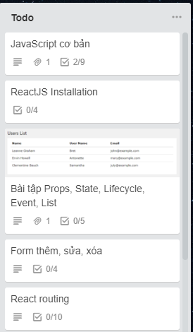

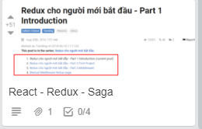

* + And the tasks that I finished:

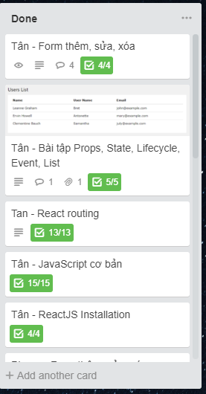

Example: 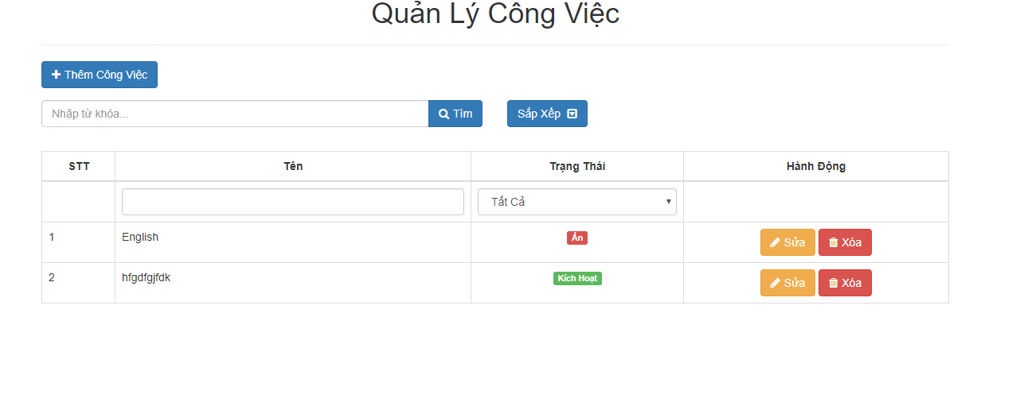

## Two soft skills related experiences:

* + Research
  + Self-study

# Chapter 4: Conclusion

## Achievements

* Be working in a professional environment to develop myself and work effectively
* Help me orientate my career path
* Know about new technologies that are popular now
* Help me know how to write clean, brief code
* Can use React JS and Redux to create single page application
* Can use mock api to create fake data
* Can use the tools of google to support in code process such as React Developer, Post man, etc
* Can use the libraries into project such as lodash, axiso, etc
* Can use github to manage source code
* Improve my soft skills
* Have more new relationships

## Conclusion

* df

## Reflection on career path

Fqazbzpr5ar